MeltinPot



MeltinPot Final Report

ISTM 631 - 601

Team 7

04/27/2020

<http://ec2-18-218-213-96.us-east-2.compute.amazonaws.com/meltinpot/homepage.php>

By Ashwin Bhide, Nikita Gambani, Nishant Goel, David Zuniga

**Table of Contents**

**MeltinPot Final Report** **4**

Description of System 4

About MeltinPot 4

Features 4

Key Functionalities 9

Main Purpose 9

Business Problem 10

Information to Access Website 11

Link to Website 11

Credentials to Access System 11

Design Elements Discussion 12

Design Elements 12

Design for Emotion 12

Uniqueness 12

Golden Ratio 12

Visual and Cognitive Contrast 12

Delight 12

Visual Lexicon 13

Color 13

Logo 13

Typography 13

General Style Notes 14

Improvements from Prototype Discussion 15

Improvements 15

Database Description 15

Features 15

User Records 15

Dish Details 15

Order Records 16

Operations 16

Login/Sign-up functionality 16

Post Dish for Sale 16

Browse Dishes 16

Order Food 16

ERD 18

Tables and Attributes 19

Relationships 19

Code 19

PHP 20

MySQL Database 22

HTML/CSS 23

Technologies Discussion 24

Software and Tools 24

Technology Stack 25

Host suite 25

Project Learning Outcomes and Challenges 26

Learning Expectations 26

Challenges 26

Appendix 27

User Persona 27

Copy Examples 29

In-App Greeting 29

Success Feedback 29

Error Greeting 29

General Message 29

Critical Failure 29

Marketing Copy 29

Design Persona 33

Team Photos 33

References 33

# 

# **MeltinPot Final Report**

## **Description of System**

### About MeltinPot

MeltinPot, founded in College Station, Texas, is a company that aims to serve traditional, home-cooked meals from different cultures across the globe. MeltinPot serves as a meeting place for users to share their cuisines with people hailing from different parts of the world. Since its inception in 2016, the company has served over 500 customers from many areas of the world. MeltinPot wishes to expand its customer base. Currently the marketing strategy is mainly targeted towards social media ads and word-of-mouth communication.

To add more customers, MeltinPot intends to create an online presence and an easier way for people to provide and order food. An online platform will help users coordinate and to meet at convenient locations, and even have their food delivered to their doorstep. To achieve this objective, a website will be created to allow users to seamlessly explore the variety of cuisines, post new dishes, and purchase their favorite meals. The creation of the website will also aid people from different areas of the world to network and foster cultural diversity.

### Features

**Search Feature**

The first feature the user may come across when viewing the website is the search bar feature as seen below:

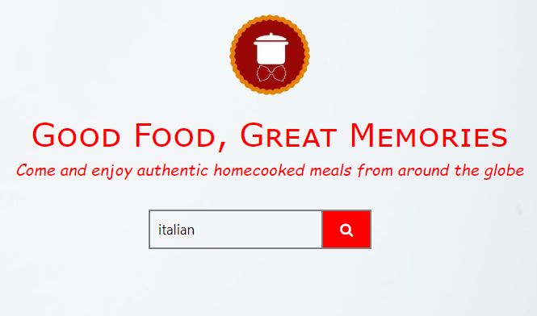

When the user enters a valid search request, they are taken to another page that brings up available dishes of the requested search. The user can filter down the dishes by type of food and price. The user is able to see a picture of the dish, its rating, and a detailed description of it, as well as the ingredients necessary to make the dish. If the user likes what they see, then they will select the quantity of the dish and press the Add to Cart button. A screenshot of the page can be seen below:

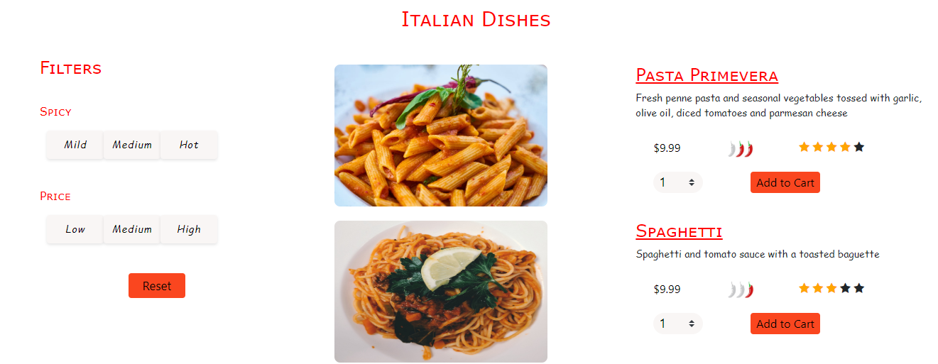

**Sign-In and Sign-Up Pages**

On the top right-hand side of the Home page, there are two buttons labeled “Sign In” and “Sign Up”. The user first clicks the sign-up button when visiting the website for the very first time. Once they enter their credentials and create an account, the user is directed to the sign-in page, where they are prompted to enter the information used in the previous page. Once the account is created and the user signs in, the user is able to view and order dishes.

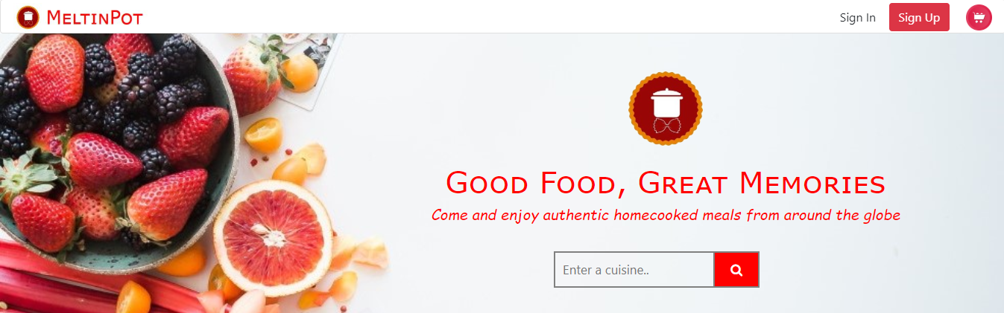

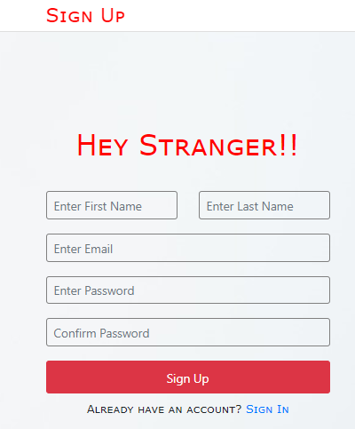

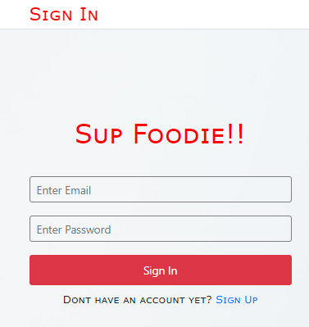

**Top Dishes Feature**

This feature is located on the bottom half of the Home page. It consists of the week’s top six dishes viewed and ordered. Here, the user can get a sense of what dishes are popular at the moment, if they are unsure what to choose. When the user hovers their cursor above one of the images, they get even more of a feel of what is included in the dish and what makes the dish so popular.

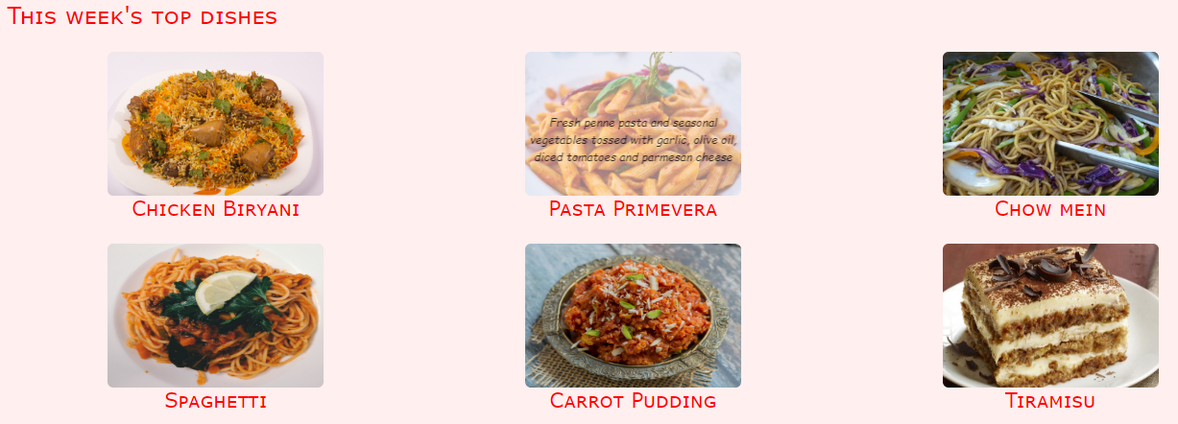

**About Us Page**

The Meet the Team Page was added in the final version of the website. This page can be accessed through the footer banner of the website under the label of “About Us”. The page includes each individual team member’s name, role on the project, a casual picture, and a short, but funny text that describes a bit of ourselves.

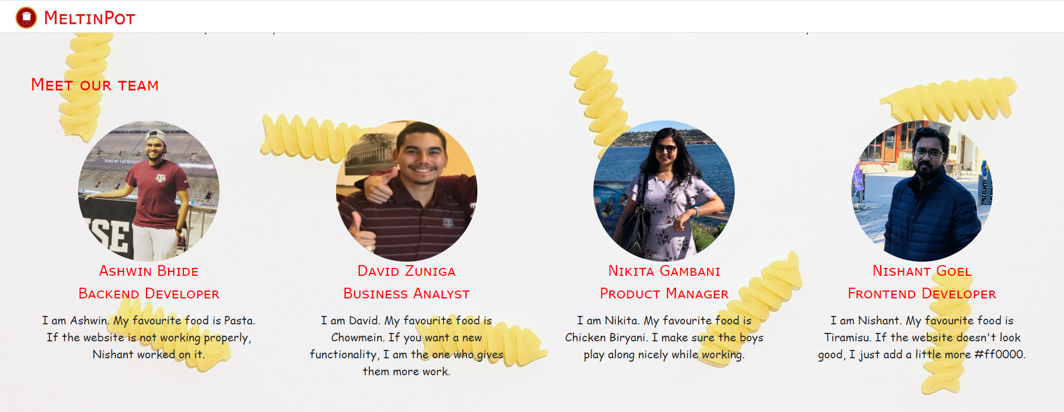

**Shopping Cart Feature**

The shopping cart button can be located on the top right of the homepage. It is symbolized with an image of a shopping cart. Once clicked, the user is directed to another page, that prompts the user to enter their address information for the delivery of their food. The page also displays the dish ordered, the quantity ordered, and the total price of the order. This feature is detailed as follows:

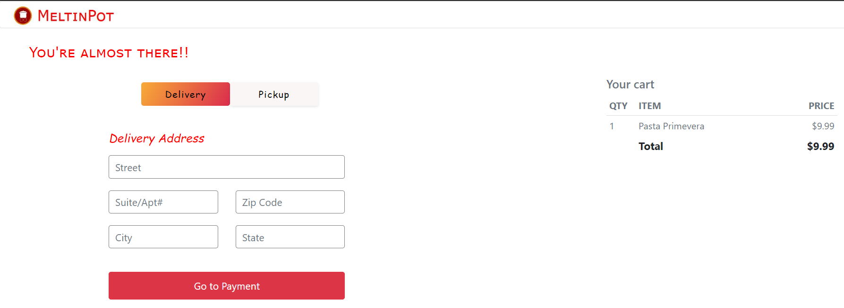

**Payment Information Page**

The Payment Information page is the last page that the user has to encounter before the order is completed and the user can obtain their food. The user enters their credentials needed to place the order. This includes their card number, name, expiration date, and the security code on the back of the card. It also displays your cart once again to make sure the user confirms that their order is right.

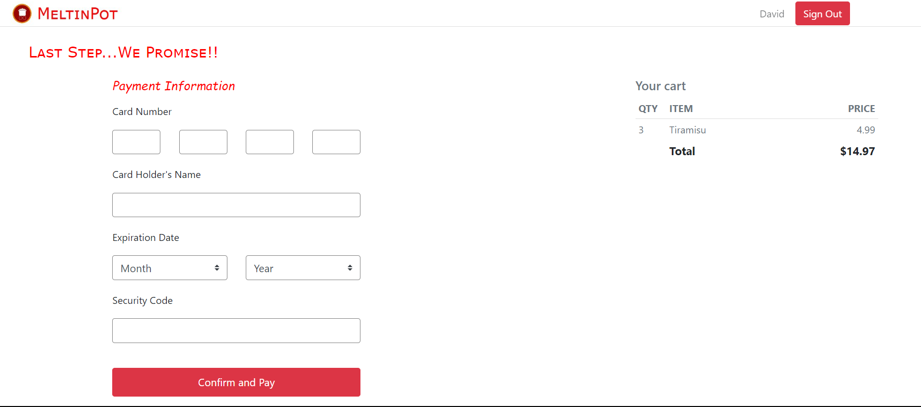

Once valid information is inputted in the required fields and the user clicks the Confirm and Pay button, then this screen appears:

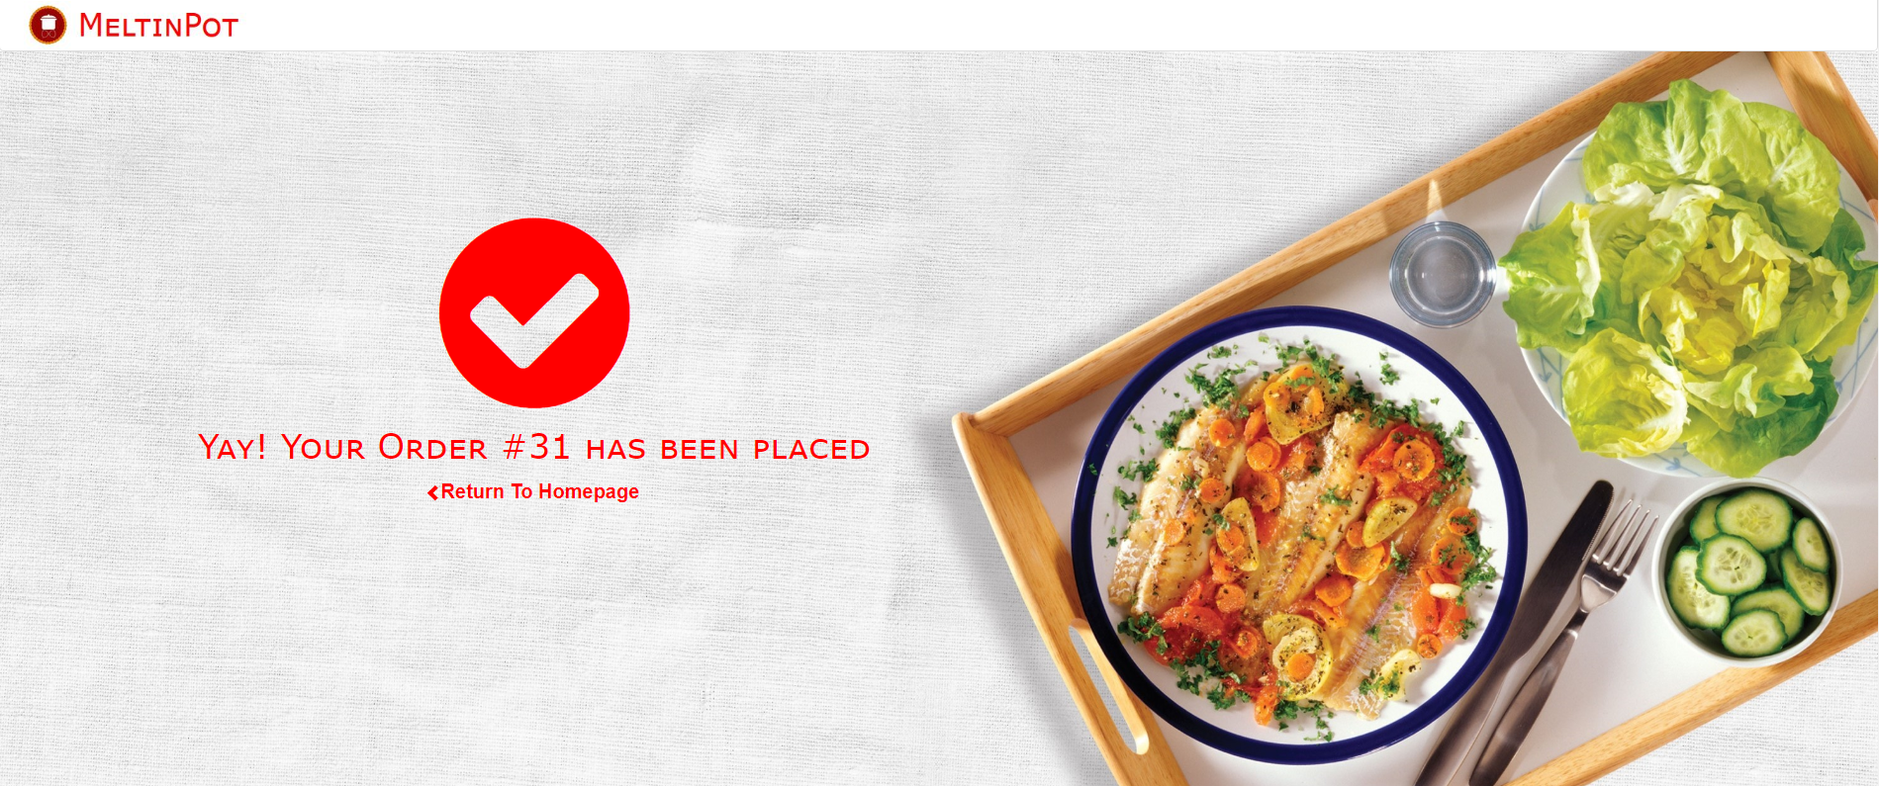

### Key Functionalities

The key functionalities of the MeltinPot website include:

* Database connectivity for user accounts, food options, and search capabilities
  + Admin page necessary for database viewing
* Navigate almost any page needed entirely from the Home Page
* Ability to add and remove dishes from shopping cart
* Very specific filters for the type of cuisine, price of the cuisine, and the rating of the cuisine for every dish uploaded and purchased

### Main Purpose

Our website aims to achieve the following outcomes:

* MeltinPot aims to be a one stop shop for customers to explore new cuisines from different parts of the world
* The website will serve as a platform for food lovers to experience their favorite cuisines by ordering home-cooked healthy meals
* MeltinPot will also provide an opportunity for people to prepare authentic regional dishes and give a taste of their culture
* The website will seamlessly work across multiple platforms such as smartphones and desktops

### Business Problem

The problem we aim to solve is to become a pioneer in the food-sharing industry. We want to be a company that is a household name and the first that customers think of when they want to try ethnic and diverse meals. We are a unique business that allows for users to order and upload food that they cook themselves. The users also have the capability of uploading a detailed description of the ingredients used so that the purchasers know exactly what is in the food that they are ordering. Having an established physical restaurant, we wish to move solely to an online presence. This is in part due to the COVID-19 pandemic, as well as the continuous trend of increasing internet use.

# 

## **Information to Access Website**

### Link to Website

<http://ec2-18-218-213-96.us-east-2.compute.amazonaws.com/meltinpot/homepage.php>

### Credentials to Access System

Username: [davidzuniga1@tamu.edu](mailto:davidzuniga1@tamu.edu)

Password: password

In the bottom right hand corner of the website is the “admin login” that allows admins to view the records inputted into the database.



# 

## **Design Elements Discussion**

### Design Elements

### **Design for Emotion**

#### *Uniqueness*

The emphasis on home-cooked meals throughout the website helps MeltinPot drive home a warm, homely, and welcoming message, and stand out among the restaurants and eateries. The casual tone of messages on the website helps establish a level of comfort with the customers and impart a homely feel.

#### *Golden Ratio*

The website extensively utilizes the golden ratio to appeal to the subconscious patterns of the human brain, rendering the website easy to use and sparking off the aesthetic usability effect. Text, image, button placements, and dimensions are planned in a way that is pleasant to the human eye.

#### *Visual and Cognitive Contrast*

The kettle-shaped logo is simple, memorable, and reflective of the comfort food MeltinPot aims to provide. The brand logo is focused on enabling customers to associate traditional, home cooked global cuisines with MeltinPot. Varying font sizes, apt use of color, and smooth design make it easier for users across all age groups to navigate the website and order the meals they intend to.

#### *Delight*

Carefully crafted pictures of prepared dishes creates an appetizing image in the minds of the customers, enabling them to engage in the process of exploring recipes and triggering a call to action for users to place an order.

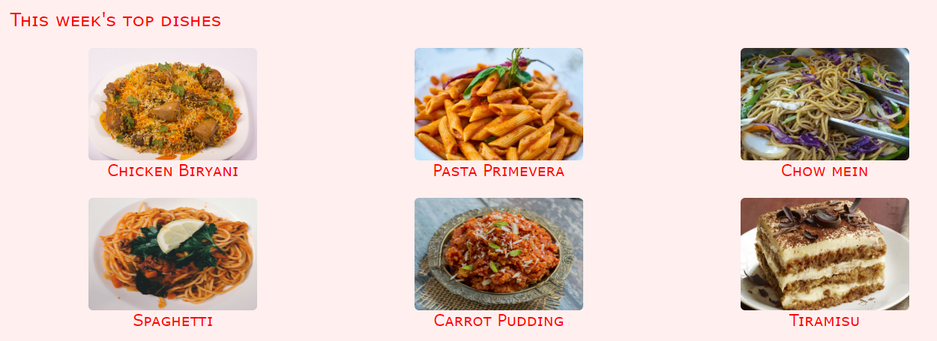

### **Visual Lexicon**

#### *Color*

The solid colors of the MeltinPot website convey a sense of boldness and stability. These colors have very high percentages of hue that show purity and sincerity. The analogous colors of red, orange, and pink display a sense of excitement and attention. These colors, being neighbors on the color wheel, promote a smooth feel and layout for the website. The hexadecimal codes for these colors are as follows:

* #ff0000 - Shade of red
* #ffefef - Shade of pink
* #ffa500 - Shade of orange

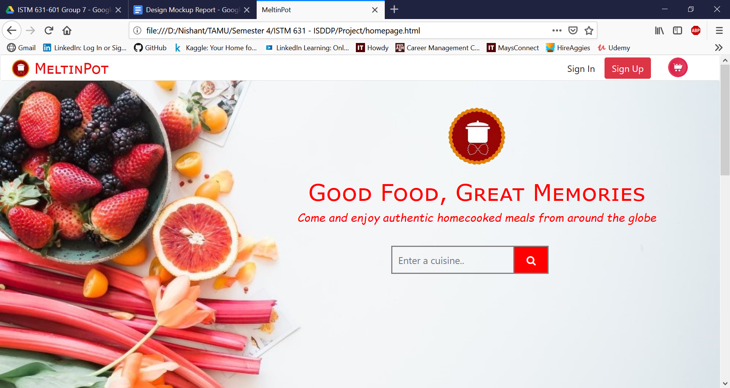

#### *Logo*

The logo for MeltinPot consists of a pot at the center of the circular shape outline. The logo also includes a single pasta shell. Both of these figures symbolize food. The colors that are included in the logo are the same ones used for the website and the reasoning is described in the previous paragraph.



#### *Typography*

MeltinPot is simple in the fonts and design of the website but consists of all the necessary features needed for users to have a great experience. The fonts are simple, sans-serif headings and the page layout mimics the golden ratio. The text for headings differs from those of labels and the colors of significant features are more eye-catching than less important features. The typeface for this website will be a Verdana font. The text throughout the website is uniform for all pages, regardless of the font size. Either of these fonts are made for computer use and are appealing to the eye. An example of the Verdana font being used is provided below:

* Lorem ipsum dolor sit amet, consectetur adipiscing elit, sed do eiusmod tempor incididunt ut labore et dolore magna aliqua. Ut enim ad minim veniam, quis nostrud exercitation ullamco laboris nisi ut aliquip ex ea commodo consequat. Duis aute irure dolor in reprehenderit in voluptate velit esse cillum dolore eu fugiat nulla pariatur.

#### *General Style Notes*

The design of the website is simple but demands attention. The rounded corners and smooth textures make the user feel at home and feel comfortable. The logo, consisting of a pot and pasta, is used sparingly throughout the website, perhaps only appearing once or twice per page. The logo does not have significant interactive abilities and is mainly used to connect a brand and its name to the website and function it serves

# 

## **Improvements from Prototype Discussion**

### Improvements

Features that were included in the prototype are:

* Database connectivity for search box to work
* Database connectivity for the sign-in and sign-up pages
* Descriptions over Week’s Top Dishes

Improvements and changes from the prototype to the final version are:

* Full database functionality
* Full feature functionality
* About Us page added and contains our name, a casual photo of each of us, and a casual description of ourselves.
* Admin page was added so that Dr. Araujo can see the database and how it works

## **Database Description**

### **Features**

### **User Records**

Users at MeltinPot will assume a dual role ie. a particular user is able to sell dishes of his/her cuisine as well as buy dishes from other cuisines. Each user will have biographical information like name, age, gender, country, address, etc. Also, the user will be able to login at our portal and hence will have a user-id, email, phone number and password associated with the account. Each user will also have a status attribute associated which will indicate whether the user is active/inactive on the platform. Based on the quality of food delivered, each user can be assigned a rating by the customers. All user records will be stored in a database to enable efficient storage, querying and retrieval mechanism.

### **Dish Details**

MeltinPot also keeps a record of the dishes that are available for sale. The dish records will contain the type of cuisine, price, type and description of the item. The seller of the dish will also display the ingredients involved in the preparation of the dish. MeltinPot will also display a picture associated with the dish to give the buyers a visual representation of the items they are about to order. All these details will be stored in a database.

### **Order Records**

Order details will be stored for each transaction that takes place on the website. Each order will have an order-id, order-line item along with the quantity, seller-id as well as the datetime when the order has been placed. The final amount will be computed and displayed to the user.

### **Operations**

Based on the user research we conducted, some of the key operations that our website will support are as follows:

### **Login/Sign-up functionality**

Users will have the ability to register an account with MeltinPot. Once the user is created, he/she can login to the portal to buy, sell and browse dishes from different cuisines.

### **Post Dish for Sale**

Users can upload the dish for sale. Each dish will be associated with a cuisine like Indian, Chinese, Thai and so on. Once the dish has been listed on the website, it can be viewed by other users.

### **Browse Dishes**

Users can browse dishes based on the cuisine type. Each dish will have a picture, description and ingredients associated with it. The user can also view the ratings associated with the seller to make an informed decision about buying the food item.

### **Order Food**

Currently, the website only supports cash as a payment option. Once an order is placed, an order confirmation along with the total amount will be displayed to the user. The user can add multiple food items to a single order.

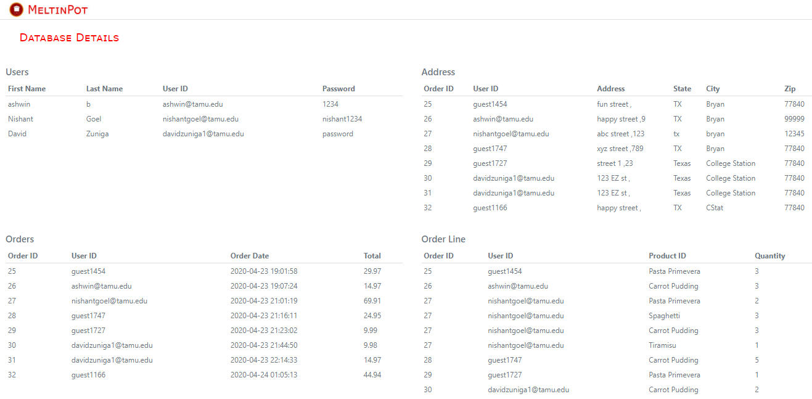

## 

## ERD

MySQL version 8 is being used for storing the user details and registration information. Please find the ERD diagram based on which are database will be modeled:

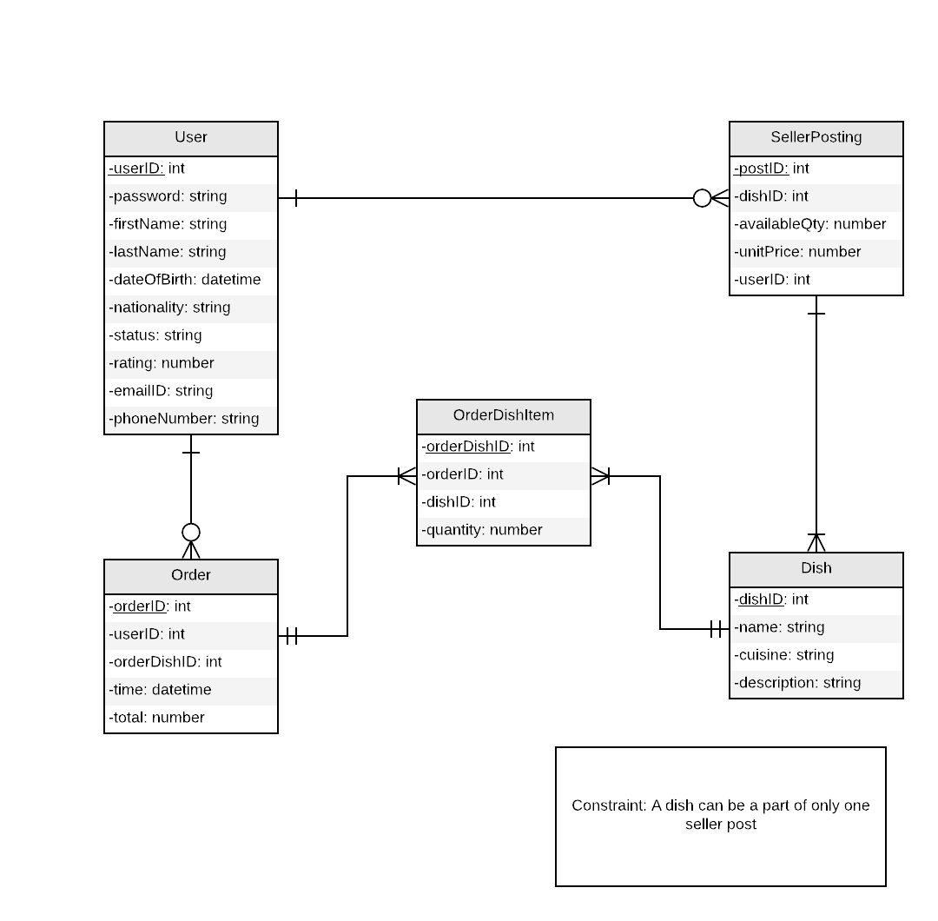

## Tables and Attributes

The tables that are included in the database are, as shown in the above ER Diagram, are as follows:

* **User table**
  + Stores user information used for the sign-in and sign-up pages
* **Order table**
  + Keeps track of the total price of the items in the cart
* **SellerPosting table**
  + Keeps track of the dish posted by users and the total quantity of that dish posted.
* **Dish table**
  + Stores dish details and the category the dish falls under
* **OrderDishItem associative entity**
  + Is an associative entity for the Order and Dish tables. It keeps track of the quantity of the dishes in the order.

## Relationships

The relationships for the table are as follows:

* **User table and Order table**
  + The user can have zero to many orders.
  + Each order can only be made by one and only one user.
* **User table and SellerPosting table**
  + The user can post zero to many dishes.
  + Each posting can be made by one and only one user.
* **Dish table and SellerPosting table**
  + Each posting can contain one or many dishes.
  + Each exact dish can only come from one and only one posting.
* **OrderDishItem associative entity and Dish and Order tables**
  + Each order and dish quantity can consist of one or many food items.
  + These one or many food items can only come from one and only order.

## **Code**

### PHP

Sign-in and Sign-up functionality

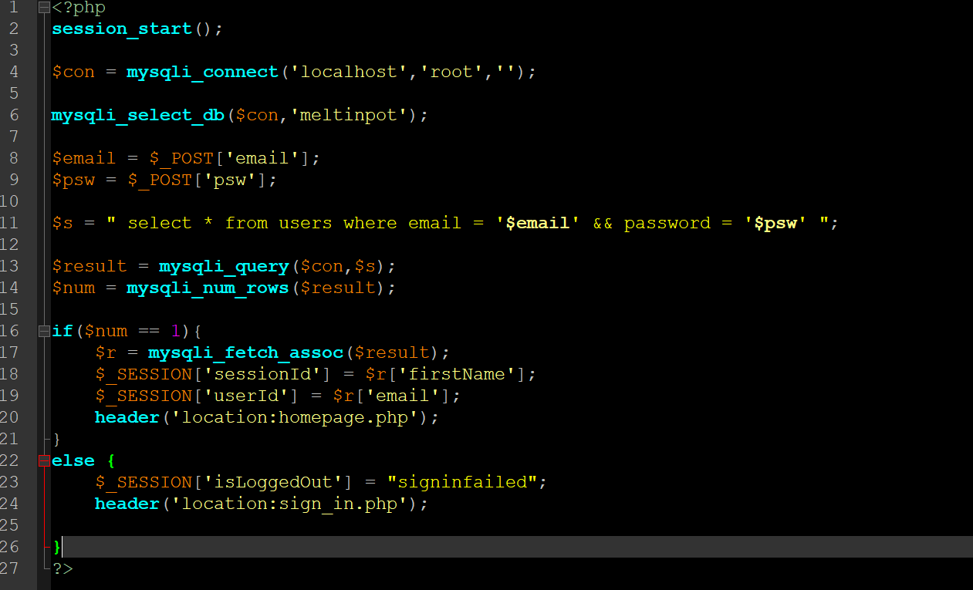

PHP connects to the backend MySQL database by creating a connection object. This object takes the server name, username and password as its arguments. In the case of the “Sign-In” workflow, the email and password is parsed from the input form through the POST action method. The username and password is looked-up inside the users table. If a query result is obtained, the user is logged-in to the system and a “session-id” is created to track the user activity on the page. If no result is obtained, the user is redirected to the appropriate error/fail page.

### 

Add to Cart (Handling session variables)

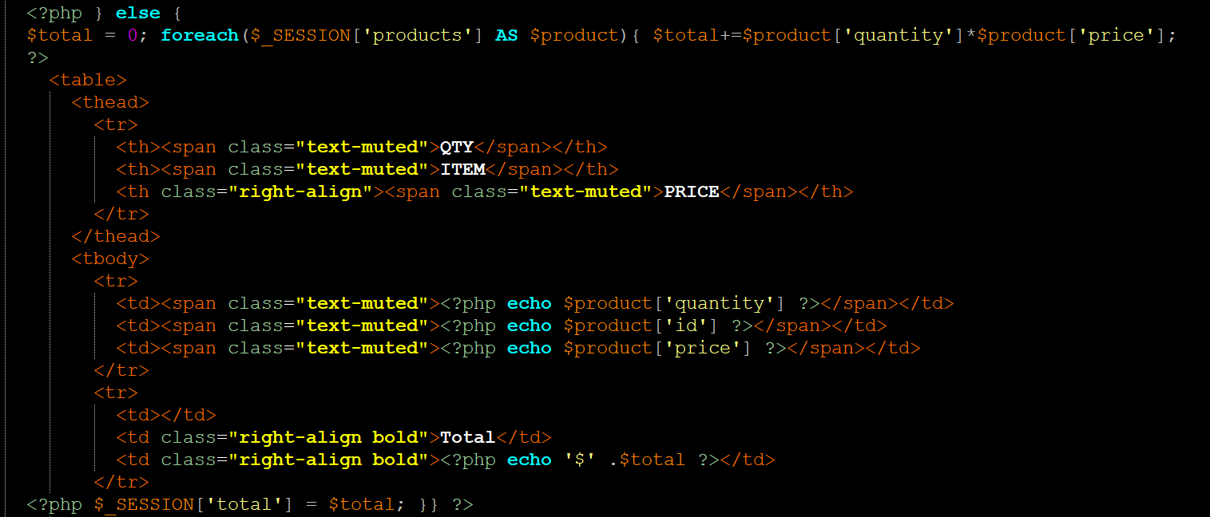

Handling session variables is the difficult part in PHP. We need to make sure that products in the cart, the active user, quantity of items selected, and the price of product is stored and maintained. We have created a “products” array to store the product-id, quantity and price of the items in the cart. We iterate over this array to display items in the cart along with the “total” at the order checkout page.

Order Confirmation

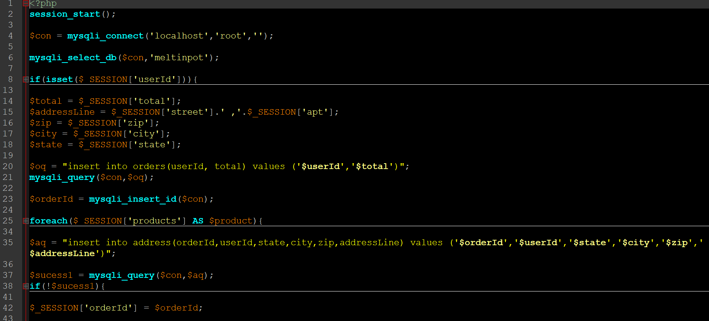

Order confirmation is one of the vital aspects of our project. We need to make sure that order is correctly recorded in the database and also include the timestamp of the order creation. Our website allows unregistered users to also place an order with us. We generate a unique-id to identify the guest user and store his/her address with the order number in the “orders” table. Each user is connected with the “orders” table to track the different orders that are placed when the user is logged-in the system.

### MySQL Database

DDL/DML Scripts

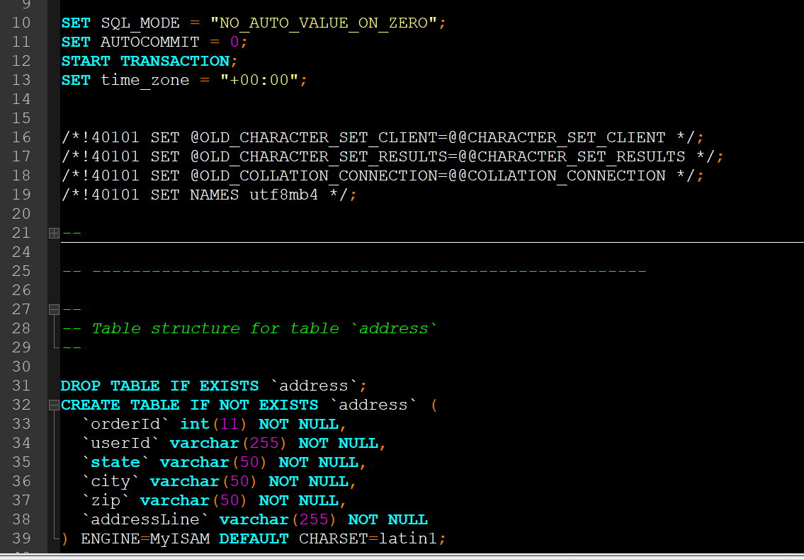

MySQL Designer View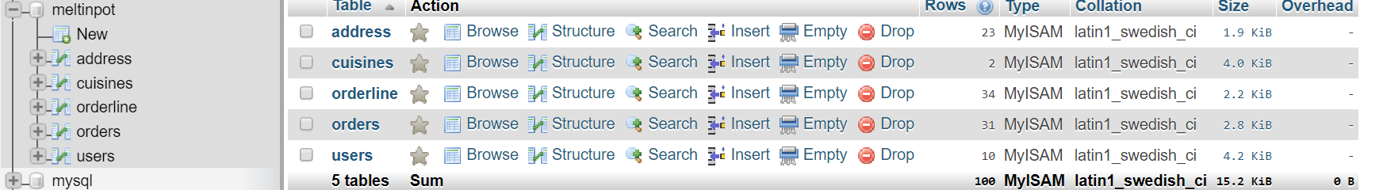

## 

## 

## HTML/CSS

HTML for homepage

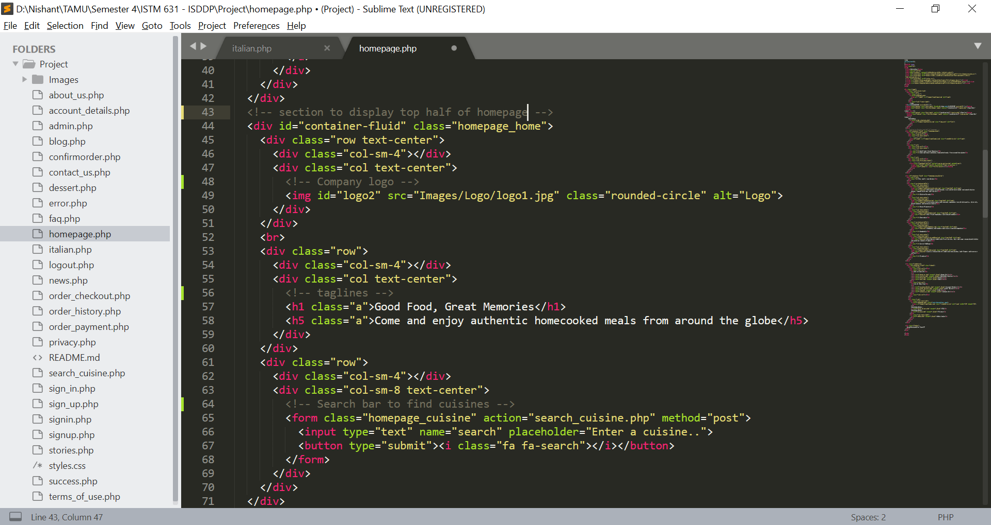

The above screenshot displayed is the code which creates the top half of the homepage with the company logo, tagline and search bar to explore different cuisines available on the website.

CSS for text on hover of mouse on image

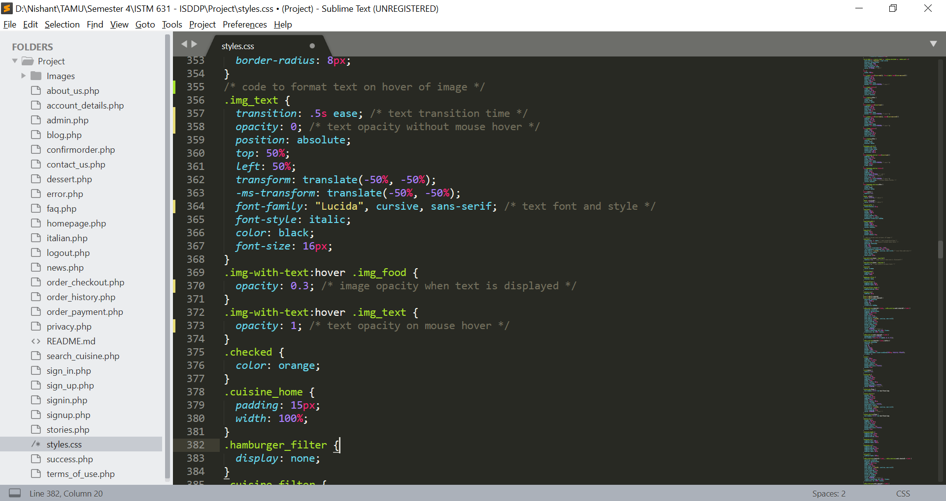

The above CSS code is used to format how text will appear once the user hovers the mouse on the image.

HTML for filter

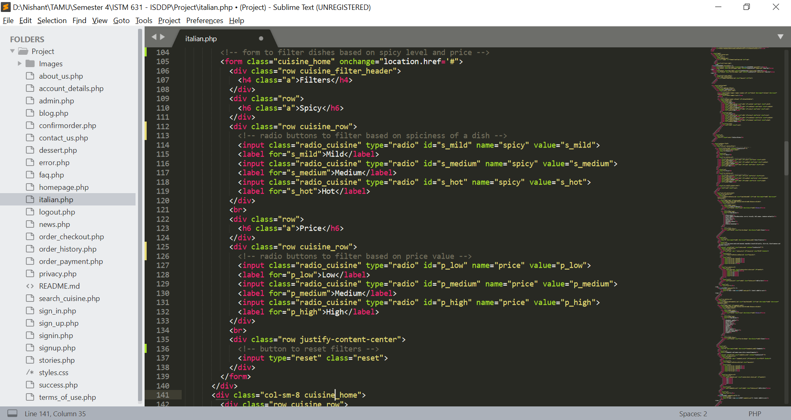

The above code is used to create the filters on cuisines page which can be used to filter out dishes on the basis of spiciness and price.

The entire code can be found at <https://github.com/ashwin-bhide/meltinpot>

## **Technologies Discussion**

### Software and Tools

We have primarily used HTML5 and CSS3 along with Bootstrap framework for the front-end development. For the backend, we have used MySQL version 8 as our backing store. The user registration and login services are RESTful services that have been developed using Spring Boot framework with PHP as the development language. Eclipse IDE has been used as the development environment for engineering the backend of our website. All interactions with the database happen through the model-view-controller (MVC) architecture supported by the WAMP Framework. The website will be hosted on Amazon Web Services (AWS) cloud instance. The Cloud9 environment will be used to install dependencies on the cloud server.

All of the above technologies are open-source and free-to-use. Hence, there will be no licensing costs.

### Technology Stack

The following technologies have been in the development of our website:

* HTML5
* CSS3
* PHP
* Bootstrap framework
* WAMP Server
* Amazon Cloud hosting
* MySQL database
* RESTful Web services

### Host suite

The MeltinPot website will be hosted on Amazon Cloud server. All the project artifacts will be uploaded to the cloud and corresponding database and software installations will be done. Once the website is deployed, Amazon server hostname with the port number and corresponding endpoints will be shared with our end-users.

# 

## **Project Learning Outcomes and Challenges**

### Learning Expectations

The goal of this project is to plan, prototype, and build a website that incorporates important web design principles, such as mobile first development, emotional design, and responsive web design. The project mimics real life corporate web development projects and as a team we intend to understand different aspects of web project planning, design, and implementation, keeping in mind a customer-first mindset.

### Challenges

There were a few challenges that we were able to overcome. One challenge was initially making the code appear correctly for the mobile device application of the MeltinPot website. At first, only the desktop version was working, and the mobile version had troubles with the responsiveness look that was necessary for functionality. This has been corrected in previous versions of the website code. Another challenge in the coding of the website was that it was difficult to write code that gave us the capability to adapt to all screen sizes. Another challenge was that we needed the text color and images to complement each other. This fix required some trial and error and took some time to do. Another challenge we encountered while coding the front end portion of the website was positioning different contents on the webpage.

## 

## 

## **Appendix**

### **User Persona**

Website Brand Traits

*Excitement*

The colors of the website promote excitement because red is the warmest and most dynamic color. Red is also known to increase one’s heart rate, which is the cause for excitement.

*Welcoming*

The feel for the website is welcoming because of the simple details and the connecting of people through sharing their personal food.

*Unique*

The website is unique because there are none out there with this idea and concept.

*Modern*

The website is modern because only today’s technology can provide a platform for all.

*Universal*

The website is universal because everyone across the earth can share food, regardless of culture or location.

*Smooth*

The features and layout of the website exhibit smooth characteristics through its color, shapes, and aesthetics.

*Memorable*

The food shared through the website by consumers can be memorable and wanting to come back for seconds.

*Reliable*

The website is reliable because it will always have the full attention of the creators and their best effort in maintaining it.

Personality Map

The website of MeltinPot is designed in accordance with the personality map characteristic of mildly dominant, yet friendly.

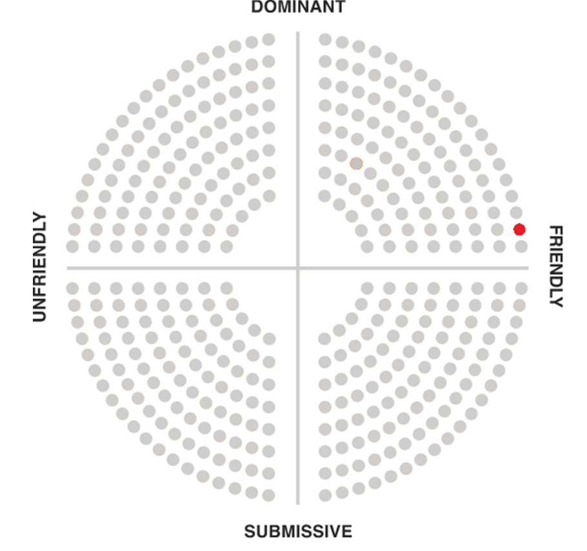

## 

Voice

The voice of MeltinPot is funny and casual and wants to have a conversation with the users. The brand talks to its users as a friend and uses phrases and emotions to connect with them Keywords like “Yay”, “Uh Oh”, “Phew'' among others help keep the conversation light and make the users feel more comfortable.

MeltinPot also tries to include the user’s name in messages to create a personalization effect, creating a strong bond between the application and the users through human interactions.

In critical situations like server failure, the voice becomes a little formal to assure its users that the company is not taking the issue lightly. Also, the brand provides an alternate course of action during the issue in order to keep the user engaged.

### *Copy Examples*

#### *In-App Greeting*

Hey George, we have missed you. What do you feel like eating today

#### *Success Feedback*

Yay George!! Your order has been placed successfully

#### *Error Greeting*

Uh Oh! You forgot to enter your time preference

#### *General Message*

Thank you George for updating your address

#### *Critical Failure*

One of our servers is currently down. Our technical team is working on it and we will be back soon. In the meantime, check out our instagram page @meltinpot

#### *Marketing Copy*

We know everyone hates creating new accounts. So you can directly login on MeltinPot using your Facebook or Google account. We won’t spam your emails or feed. Promise!!

Wanna tell others about MeltinPot?? Follow us on Twitter and Instagram at @meltinpot.

User Persona 1

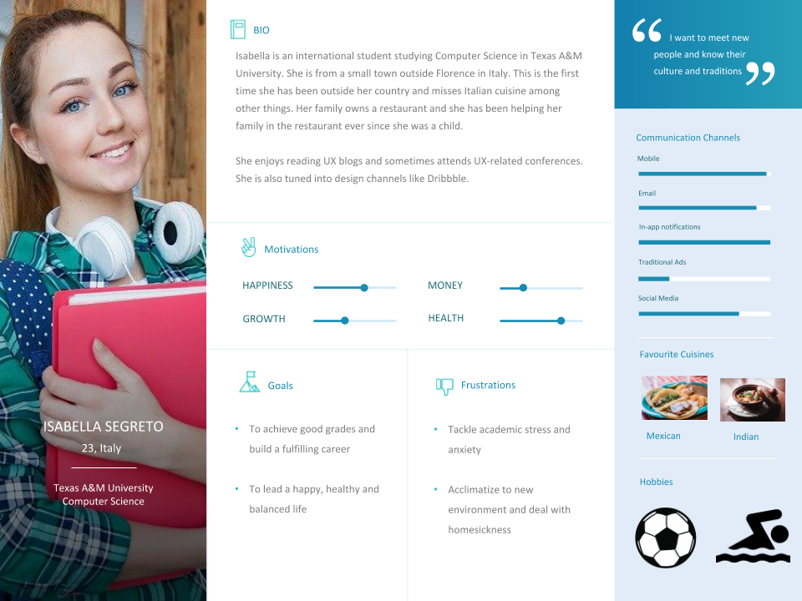

User Persona 2

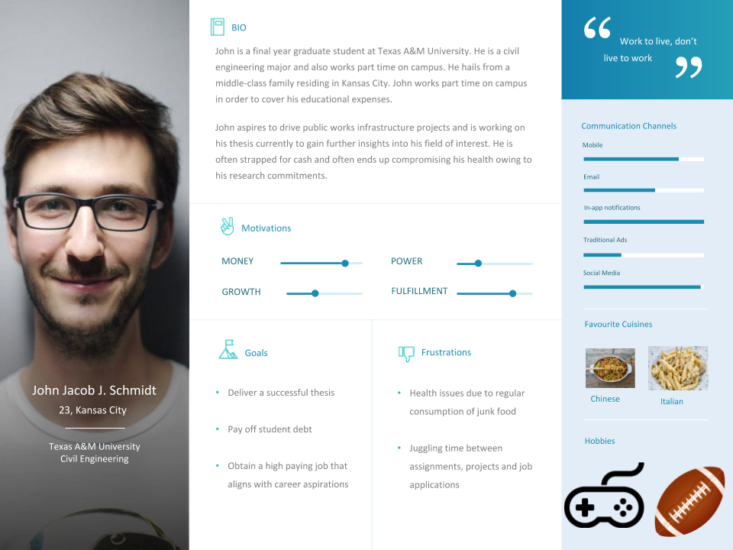

User Persona 3

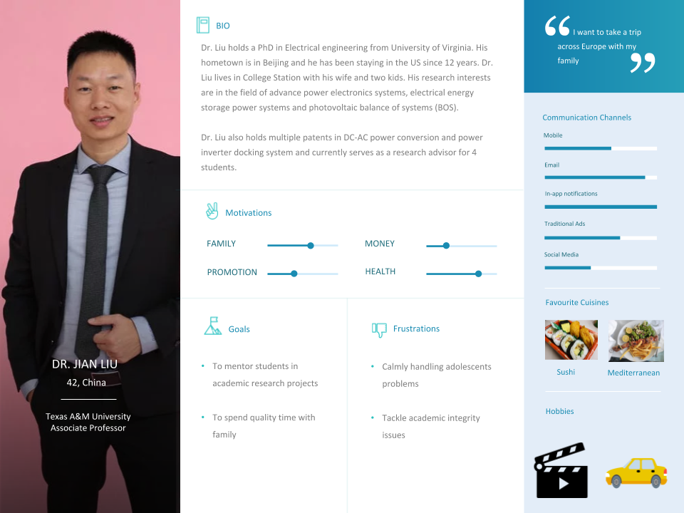

MeltinPot is a great platform for users like Isabella to get to know people from all around the world and their unique, authentic, and exotic cuisines. Isabella can use MeltinPot not only to explore various cuisines all over the globe like mexican, indian, etc., but also cook and serve home-cooked Italian meals for customers hoping to get a taste of the Italian cuisine. MeltinPot is a great platform for students like John to gain access to affordable home-cooked nutritious food, and relieve students like John from the daily stress of eating healthy, while not burning a hole in their pocket. This platform will help provide students like John with meals that are flavorful and healthy unlike restaurant food. MeltinPot is also a great platform for professors and their families like Dr. Liu, to bond over multi-national cuisines, and also contribute to the student community by cooking and serving healthy meals prepared at home. To summarize, MeltinPot will help students focus on their academic and personal development while taking care of their health and taste buds, while also providing a platform for cooking enthusiasts to showcase their culinary skills and share their love for food.

### **Design Persona**

Responsiveness

The website responds to the changes in device size. The following changes can be seen when the website is opened on a mobile device.

* Changes in background image
* Removal of links from the navigation bar
* Resizing of images and fonts
* Collate multiple columns into a single column with multiple rows

## **Team Photos**

## 

## **References**

* <https://www.freelogodesign.org/>